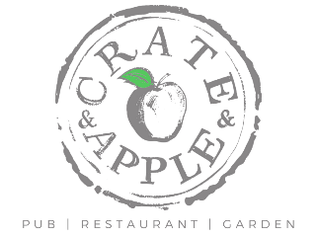
DESSERTS
. Brûléed Almond & Coconut Rice Pudding, Carrot & Cinnamon Jam, Candied Almonds (VE / NG) £7.50
. Affogato – Madagascan Vanilla ice cream, Honeycomb, Espresso shot £7.00 (V)
. Frozen Liquorice Parfait, Coconut Marshmallow, Raspberry Coulis, Beetroot Sherbet £7.50
. Chocolate Moelleux, Pistachio Ice Cream £8.00 (V)
. Seasonal Crumble, Custard £7.00 (V)
. Selection of Fine Cheeses & Accompaniments £10.00
PORT - £4.00
. 50ml Cockburns Special Reserve Port
. 50ml Fonseca Porto Terra Prima Organic Port

DESSERT WINE 125ml Glass Bottle 50cl
. Clos du Gravillas Muscat de Minervois £8.00 £29.00

HOMEMADE ICE CREAM AND SORBET
All Churned here on site - Choose 3 Scoops for £6.00 or £2.50 per individual Scoop

Ice Cream (NG) Sorbet (NG - VE)
. Madagascan Vanilla . Mango
. Chocolate . Raspberry
. Salted Caramel . Passionfruit
. Pistachio

COFFEES and CHOCOLATE LOOSE LEAF TEAS
(Kent & Sussex Tea Company)
Reg Large . Black Tea - £2.50 . Speciality Teas -£3.00
. Americano £2.40 . English Breakfast . Rooibos
. Espresso £2.10 £2.50 . Portsmouth Blend . China Green Tea
. Flat White £2.60 £3.00 . Sussex Blend . Earl Grey
. Cappuccino £2.60 £3.00 . Chamomile
. Latte £3.00 . Cherries & Berries
. Hot Chocolate £3.00 . Fresh Mint

All Dishes Subject to Availability
Please ask for any further allergy information (V) Vegetarian, (VE) Vegan, (NG) Non-Gluten